IEEE AP-S/URSI 2027 ICCK Site Visit Report
October 6–7, 2026 Kyoto Prefectural Government / Kyoto International Conference Center (ICCK)
ICCK, designed by architect Sachio Otani, is a landmark of Japanese modernist architecture. Its bold composition of upright and inverted trapezoids is harmonized with Kyoto’s natural setting, including Lake Takaragaike and Mt. Hiei.
Purpose : To inspect the ICCK venue environment for IEEE AP-S/URSI 2027 and incorporate the findings into operational planning, including WIE-related activities.
Main Areas Review: main hall; outdoor garden and common areas; WIE Forum venue (SWAN Room); and proximity to the adjacent hotel.
Related Review: the conference venue, hotel, and related facilities as an integrated whole, with particular attention to participant flow and the operation of related events.
■ 1. Preparatory Visit to the Kyoto Prefectural Government (October 6)
Yuan and Rikuta, together with Kurokawa from AIST, visited the Kyoto Prefectural Government and met with Andachi and Yasui from the Department of Commerce, Labor and Tourism and Director Soma from the Board of Education. The meeting confirmed that Kyoto Prefecture has more than 50 high schools and that outreach and publicity for high school participation will be promoted. For the AP-S/URSI 2027 high school program, the application deadline is planned to be extended to the end of January 2027; distribution of information to high schools is possible, and AP-S promotional items are also being considered.
■ 2. ICCK Site Visit (October 7)
■ 2.1. ICCK Main Hall
The Main Hall was inspected on site, including the stage, seating, ceiling height, lighting, and overall spatial configuration. The visit provided practical information for planning participant entry and exit, stage operations, and signage on the conference days.
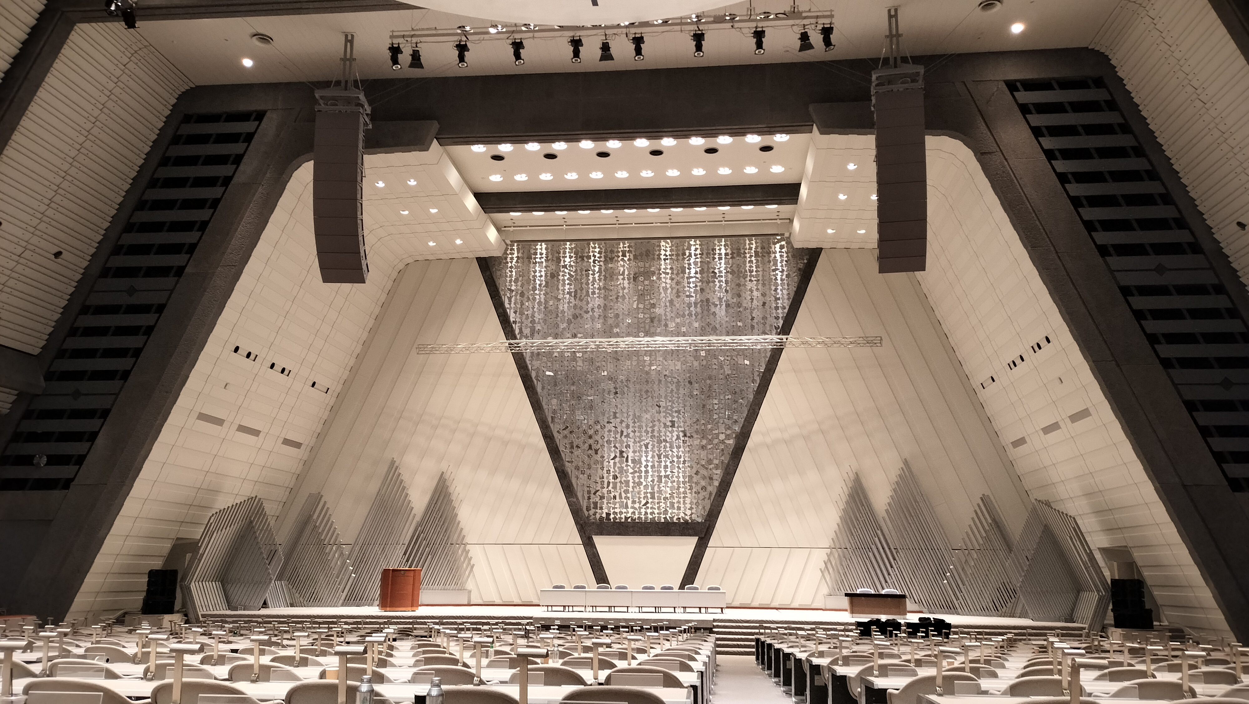
Photo 1 ICCK Main Hall
■ 2.2 Outdoor Garden, Common Areas, and Participant Flow
The outdoor garden and surrounding common areas were also inspected. These spaces can support breaks, networking, gathering, and commemorative photography, while allowing conference participants to interact in an environment that highlights both the architecture and natural setting of ICCK.
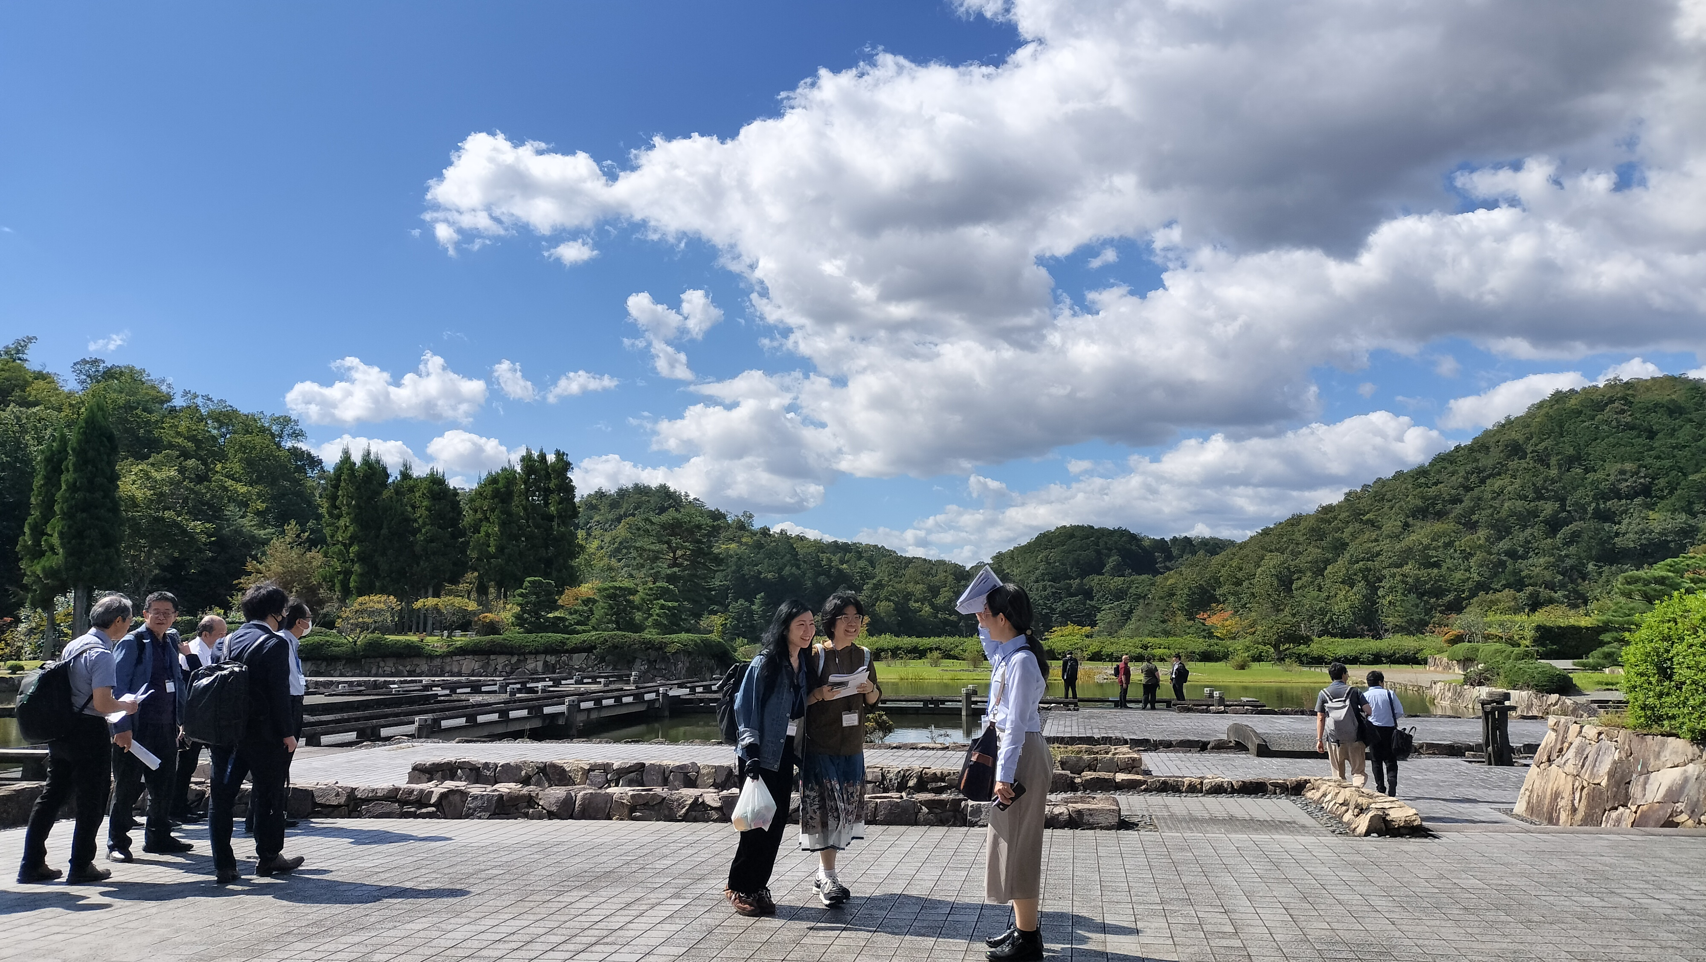
Photo 2 ICCK Outdoor Garden
■ 2.3. WIE Forum Venue: SWAN Room
Based on the site visit, SWAN Room (Banquet Hall SWAN) was confirmed as the planned venue for the WIE Forum. Located on the first floor, the 540 m² room features full-height glazing facing the Japanese garden. It can accommodate 90 participants in classroom style, 240–250 in theater style, and 300 for a standing reception. In addition to technical talks, the open setting is well suited to networking and next-generation exchange. The detailed room layout, AV setup, and hybrid delivery will be developed further.
Reference photo (ICCK official website): Banquet Hall SWANOfficial photo
[Operational Considerations]  • Seating layout and capacity  • Registration, speaker movement, Q&A flow, and budget  • Signage and commemorative photo space | [Technical Considerations]  • Projection, microphones, and audio system  • Online connectivity / hybrid delivery  • English/Japanese language switching and captioning
■ 2.4. Proximity to the Adjacent Hotel
The Prince Kyoto Takaragaike was viewed from ICCK, confirming the close proximity of the conference venue and the hotel. This is important for minimizing travel burden for conference participants, invited speakers, and committee members, and for planning clear guidance between the accommodation and the conference venue.
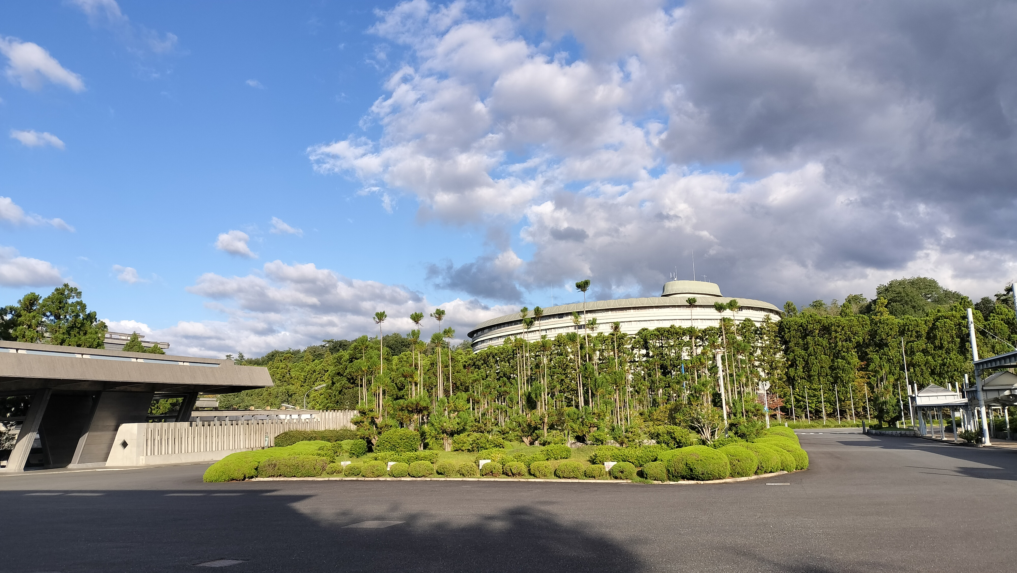
Photo 3 The Prince Kyoto Takaragaike viewed from ICCK
■ 3. Summary and Next Steps
• The October 6 meeting with Kyoto Prefecture provided a concrete basis for high school outreach, while the October 7 site visit confirmed the ICCK Main Hall, outdoor garden and common areas, SWAN Room, and the proximity of the adjacent hotel.
• For the WIE Forum in SWAN Room, seating, AV, hybrid delivery, and participant guidance will be finalized in line with the program.
• Procedures for welcoming next-generation participants, including high school students, should be prepared early, covering registration, chaperoning, gathering, networking, and commemorative photography.
• Venue-related action items will be compiled, with responsibilities and deadlines clarified and progress tracked by the Organizing Committee.

